Post Customer Down Payment - Normal

S.NO. : 02- FI-AR- 01

TRANSACTION CODE : F – 29

ACCESS PATH :SAP Easy Access Accounting Financial
Accounting Accounts Receivable Document Entry
Down payment Down Payment

We get “ Post Customer Down Payment” Header data” screen ;

Required Fields:

Document date : To be entered
Account : To be entered (Customer A/c Number)
Spl. G/L Ind. : To be set at “A” (down Payment on current asset)
Post date : Default
Amount : To be entered

Rest all other fields viz, Doc Type, Period, Companycode,Currency/Rate are default after they are entered for the first time.

We get the Screen “Post Customer Down Payment - Header Data“ incorporating the above mentioned required fields as under;

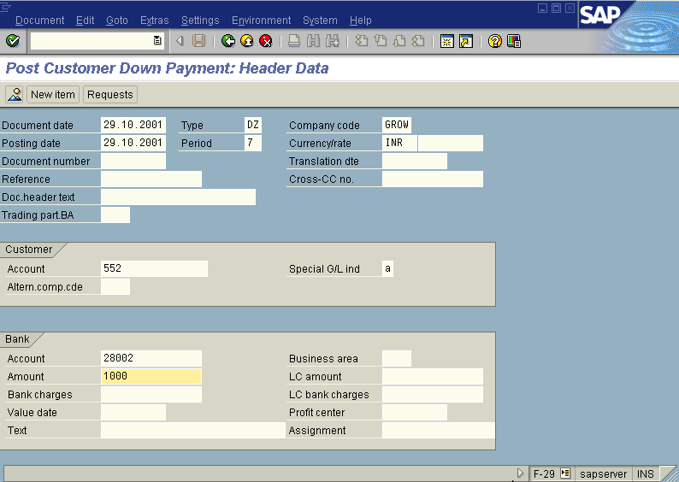

Press Enter button

We get the Screen “Post Customer Down Payment - Add Customer Item” as under; where under Amount, Due date, Sales doc. (Sales Order with Line item)fields to be entered.

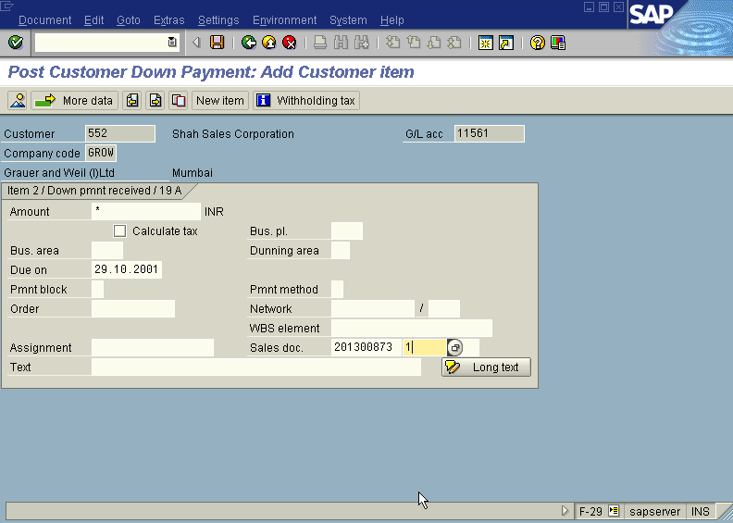

Press Enter button

This above Screen will change to “Post Customer Down Payment - Correct Customer Item”

The payment block field in the above screen will show “A” (Blocked for payment)

Press Enter button

Press Save button

The system will display a message as under

Take a note of the document number ; 1400086.

This is the stage where “Post Customer Down Payment” stage is complete

The document can be seen from Document Display from the top left hand side of the main screen “post Customer down payment - Header Data“ OR from Transaction code FB- 03 .The Document overview screen will be displayed as under showing the entries.

